Methods, Tools and Devices example

COSH-tool
Developed by: SINTEF Energy Research
Date: 27-11-2018
Type: Tool

Introduction:
COSH-Tool is a software written in Python used for quantifying fluctuations in water level and discharge which may occur in rivers subjected to hydropeaking. COSH-Tool was developed at SINTEF Energy as a part of the CEDREN EnviPeak project (Norwegian Research Council, Grant number 193818), with the aim of providing characteristics of hydropeaking events in regulated rivers, in order to classify the hydropeaking regimes of rivers. The tool enables the analysis of long time series of water level or discharge by applying an automated processing to the time series. It provides a set of indicators that characterize fluctuations of water level and discharge in rivers and lakes/reservoirs.
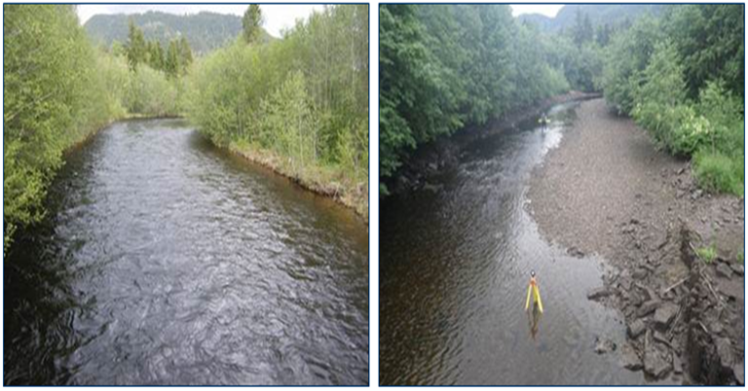
Figure 1: The river Lundesokna in Norway downstream of a peaking hydropower plant.
Author: Julie Charmasson
Source:
Description: The river Lundesokna in Norway downstream of a peaking hydropower plant.

Application:
COSH-Tool can be applied to any water level or discharge time series provided by measurements (field work) or simulation (numerical modelling). The analysis of the time series with COSH-Tool does not require any coding from the user and is executed through an interface.
Input files: The input file is a water level or discharge time series. COSH-Tool handles time series with typical time step ranging from minute to hour.
Output files: COSH-Tool computes a set of parameters that characterise water level and discharge fluctuations. The parameters can be classified in three categories: 1) magnitude of the variations; 2) timing and rapidity; and 3) frequency. The parameters are listed in Table 2.
Table 1: List of parameters computed by COSH-Tool
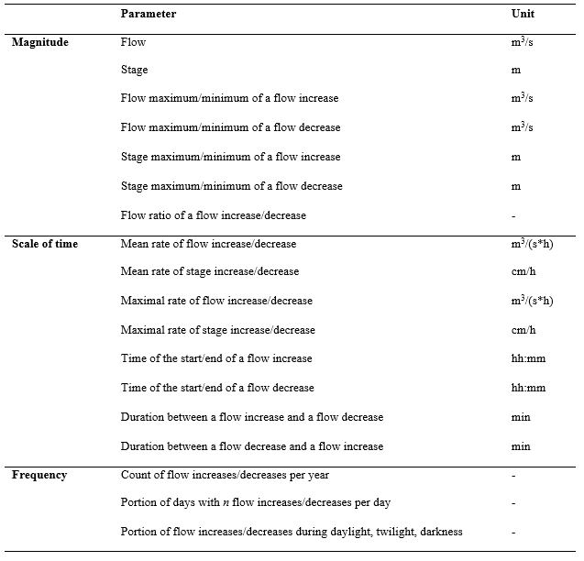
Author: Julie Charmasson
Source:
Description: List of parameters computed by COSH-tool.

The output from COSH-Tool consists in a table with statistics of the magnitude and timing parameters (category 1 and 2) and a set of corresponding graphs. Statistics are min, max, mean, median, standard deviation and percentiles. They can be computed for the entire time series, as well as on a monthly, seasonal and yearly basis. Statistics are also displayed in the form of box plots.
COSH-Tool also provides values and graphs for all frequency parameters (category 3), namely distribution of peaks throughout the day (Figure 2), number of peaks per day for each year of the time series (Figure 3), and total number of peak events per year.
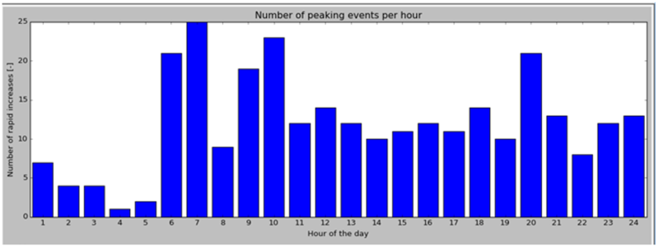
Figure 2: Distribution of peak events though the day.
Author: Julie Charmasson
Source:
Description: Distribution of peak events though the day.

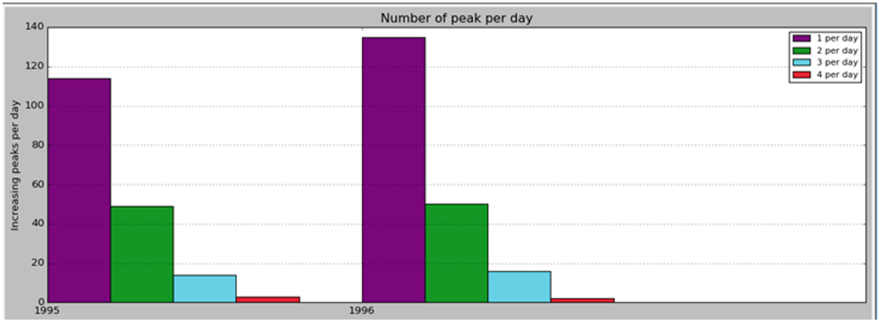
Figure 3: Number of peak events per day for each year of the time series.
Author: Julie Charmasson
Source:
Description: Number of peak events per day for each year of the time series.
Additionally, the light conditions (day, twilight, darkness) at the time of the occurrence of the peaks can be computed. A graph provides the proportion of peaks occurring at the different types of light conditions per month (Figure 5).
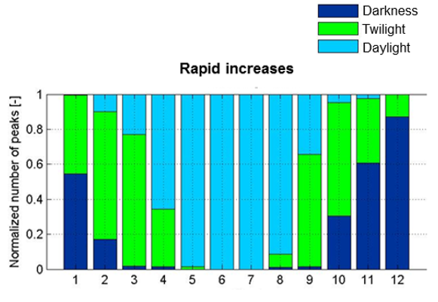
Figure 4: Distribution of peak events though the day.

Author: Julie Charmasson
Source:
Description: Distribution of peak events though the day.

Other information:
COSH-Tool is free to use after agreement with SINTEF Energy Research.
Relevant literature:
Sauterleute J. and Charmasson J. 2014. A computational tool for the characterisation of rapid fluctuations in flow and stage in rivers caused by hydropeaking. Environmental Modelling & Software 55:266-278.
Charmasson, J. 2016. COSH-Tool, a computational tool for the characterization of rapid fluctuations in flow and stage in rivers caused by hydropeaking. Proceedings of 11th International Symposium on Ecohydraulics, Melbourne, Australia.
Caetano, L., Pinheiro, A. and Boavida, I. 2018. Analysis of the effects of a hydropower plant in the downstream fish habitat. COSH-tool application. Proceedings of 12th International Symposium on Ecohydraulics, Tokyo, Japan.

Contact information:
Julie.charmasson@sintef.no

